this

* **Global object** in a function invocation

Global object

* Determined by the execution environment
* In a browser, the global object is ‘window’ object

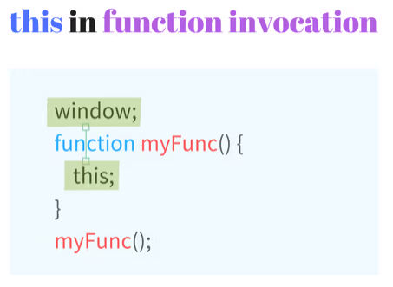

Example code:

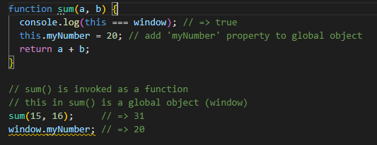

At the time sum(15, 16) is called, JavaScript automatically sets this as the global object (window in a browser).

When this is used outside of any function scope

* Also equals to the global object (‘window’ for browsers)

